Report- Uttarakhand District-Level Programme 19th Sept 2024

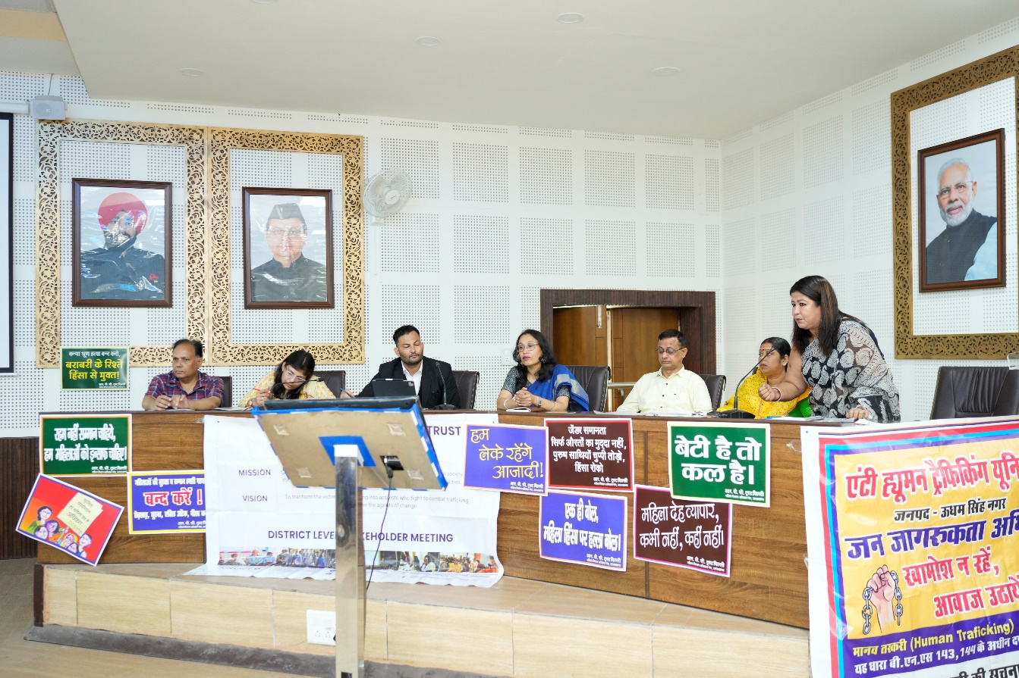
As a result of Uttarakhand Meeting March 2024, various district level programme were planned in the region of Uttarakhand to initiate a dialogue of various issues related to violence against women and children and the issues of Human Trafficking specially in the cross-border regions of Uttarakhand.
The first district level programme was held in Rudrapur on 19th Sept 2024 which was organized by RBC Trust (Ramola Bhar Charitable Trust) and Mahila Samiti initiated by Ms. Heera in Udham Singh Nagar. This event was themed on violence against women and human trafficking keeping in mind the increasing rate of crime against women in US Nagar District as reported by various newspapers and the community members specially located areas bordering Nepal.
Various government dignitaries and representatives from DLSA, AHTU, deputy CMO (Chief Medical officer), ICDS (Integrated Child Development Services), SSP (Senior Superintendent Police), One Stop Centre, DPO, PCPNDT, women and child district officials, Mahila helpline, CDPO mahila kalyan were present. Some Asha workers, Anganwadi workers, legal practitioners, some educational institutional representatives, some NGO representatives, Panchayat leaders, community leaders and committees, press etc., were also present and participated in the discussion. Individuals from the communities located in the Nepal bordering regions were also present which amounted to more than 100 people gathered in the event.

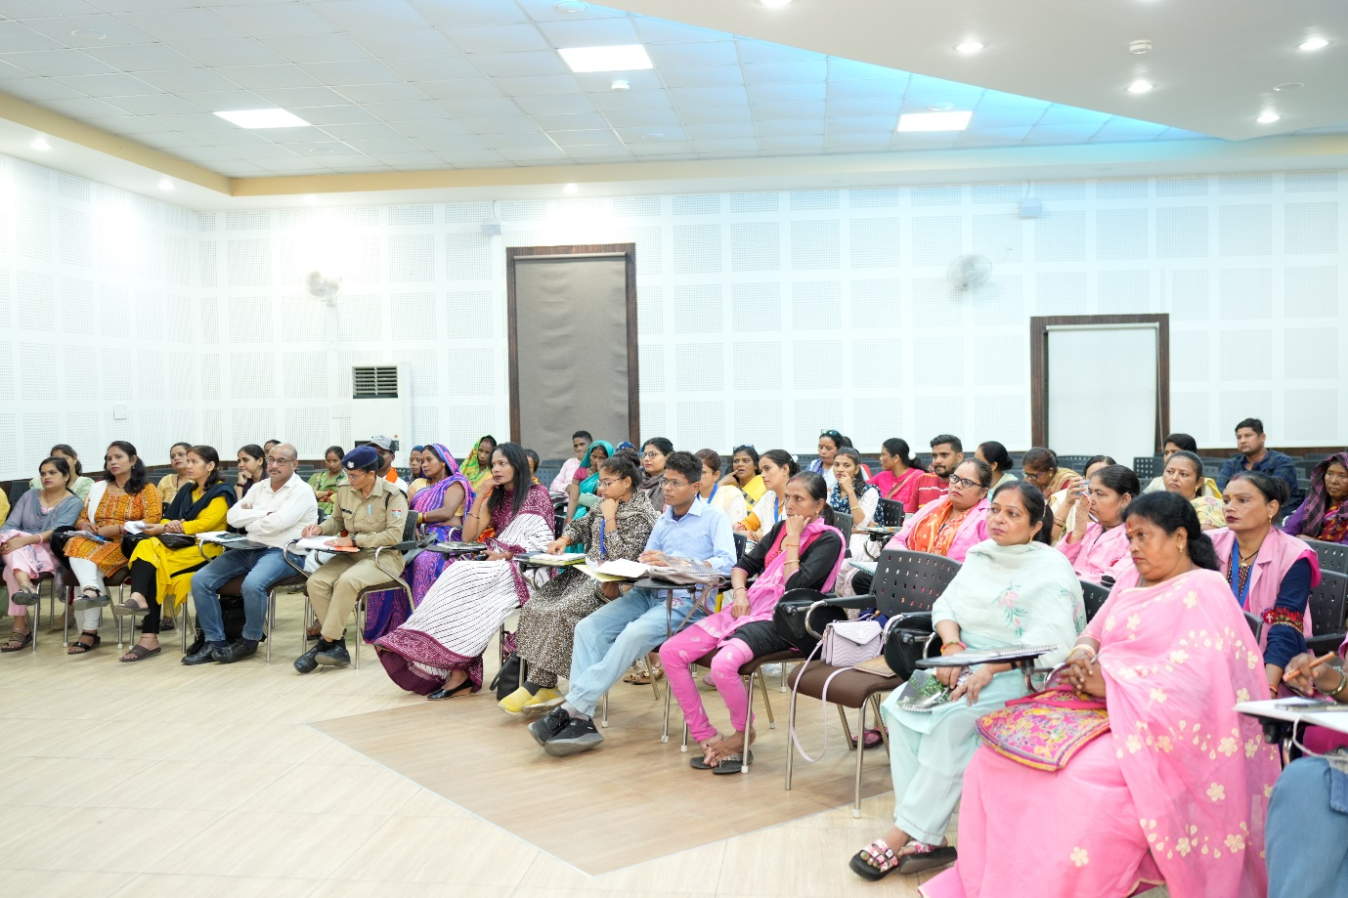
The discussion began with a warm welcome of all the present dignitaries. A brief introduction of the event was given by Ms. Hira Routela, stating the need to focus on various kinds of violence happening against women and children in Udham Singh Nagar.
The discussion was carried forward by Ms. Smritikana Ghosh Paul who introduced RBC Trust elaborating on its history. Referring to many years of experience in the field she gave in-depth examples of the various types of atrocities inflicted upon women and children and the risks and tragedies they face to get justice for themselves.
The event moved towards PPT presentation wherein Ms. Narayani Bhattacharya stepped in and spoke about STOP’s activities and its connections with national and international committees. She briefly explained the types of support STOP gives to the at-risk women and children. Thereafter, with the help of PPT Ms. Shirine Marian Tigga spoke about the alarmingly increasing rate of violence and oppression against women in Uttarakhand specially in US Nagar through secondary data (internet and newspaper articles). Each and every district was thoroughly examined. This PPT presentation created a base for discussion.
Various dignitaries were invited one by one to come in and share their comments and opinions. Firstly, DPO (District Programme Officer) came in and spoke about preventive measures like helpline numbers and people being more aware about the crime rates happening in all the districts. Child helpline representative elaborated upon POCSO Act and explained how it is an "evolving act". Mr. Miraj, an advocate from DLSA (District Legal Services Authority) spoke about how the women are subjected to complex situations of human trafficking and other forms of violence, both inside their homes and outside, and briefly explained how rescuing them becomes filled with complications. Filing their cases often requires undertaking a lot of risks especially from the side of the advocate.
Ms Smritikana added information about child marriage even prevalent today in the interior areas of the country, and its relation to POCSO. She also spoke about cybercrime elaborating upon identity theft or making fake identity that leads to trafficking. In continuation, Ms Hira added about child marriage prevention through the helpline 1098, and the loopholes people find to deter from it. She also gave examples where after even after calling the helpline 1098 and filing a FIR, people have still been made to marry forcibly in the mandir on the same day the complaint is reported.
AHTU (Anti-Human Trafficking Unit) US Nagar representative spoke about how human trafficking also takes place through luring strategies like offering employment opportunities to the village girls promising an improved lifestyle and idea of getting more money without much labour. The representative also shared about cases where parents sell their children to meet their needs. They spoke about a few cases. She explained a case wherein a 6-year-old child’s relative initially raised her as a foster daughter for 12 yrs and thereafter started taking her home-to-home for sex work. There was thorough investigation and this woman responsible for the child’s abuse was eventually arrested. The representative ended by providing precautionary guidelines to the audience to be beware of strangers and not to share any domestic problems with strangers.
PCPNDT Cell representative (Pre-Conception and Pre-Natal Diagnostic Techniques, National Health Mission officer) Pradeep Maher, presented a PPT on PCPNDT Act elaborating on the issue of low sex ratio in Uttarakhand especially in Pithoragarh. He stressed that in the state of Uttarakhand alone this issue is highly prevalent and shared a horrific incident of police finding 250 female foetuses in a septic tank in a hotel’s backyard.
From One STOP Centre, US Nagar, Kavita handling Nirbhaya Cell spoke about various services provided by their department. She explained how counselling and medical services are required for women at-risk and emphasised the importance of FIR for abandoned and suffering women. Police facilitator officer as well as legal advocates offering their services can be reached out to at One Stop Centres. She added that shelter for women and girls suffering from violence is available up to 1.5 months.
Ms Saroj from an NGO called Mahila and Bal Sewa Samiti came forward to share few thoughts. She said that parents should at least use about an hour every day to speak with their children and understand their innermost problems and fears and challenges. She also spoke against the traditional notion of "Meri badnaami hogi" and how such thinking can impact the suffering women and hinder the process of achieving justice.
An educational institute representative entered the discussion and spoke about the importance of normalizing conversations about sexuality with one’s own children, especially about good and bad touch. He shared his own experiences of facing cyber-crime and provided different examples.
A community woman representing her tribal village, mentioned a harrowing story of her daughter being molested by boys. When she went to seek help from the police, she faced humiliation as the police complained to her for raising a ‘character-less’ child.

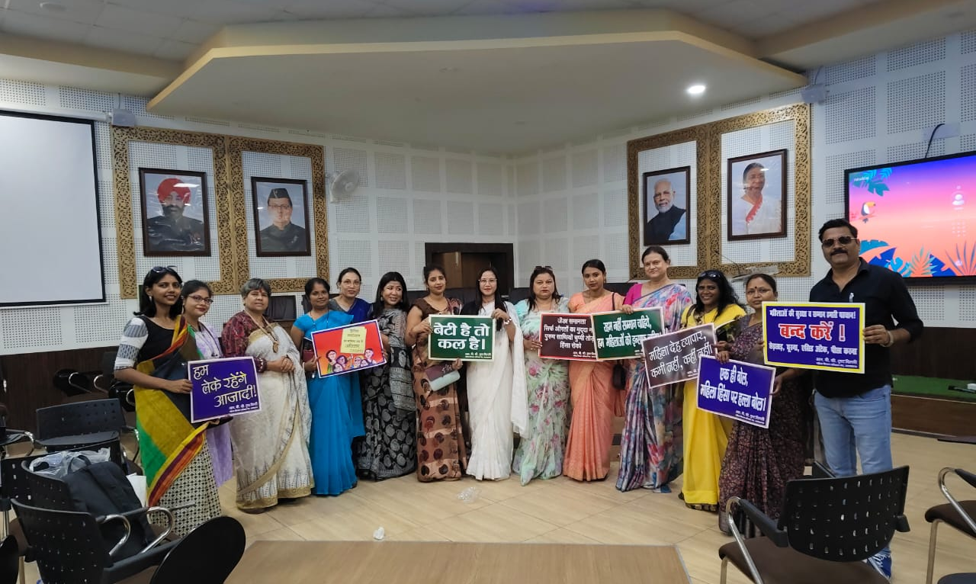
In the latter part of the event some suggestions were given by various participants. Some representatives suggested to have awareness programmes at village levels in Uttarakhand. Some representatives suggested awareness programmes at school level especially focusing boys with the aim to create long term effect of change in the boys’ behaviours towards girls. Some also suggested an action plan to create awareness at primary level might bring about a rapid change in awareness.
Therefore, the discussion on increasing violence against women was effective, informative and impactful. We hope that these discussions will spread across the district and bring about necessary changes in the future!

