STOP UTTARAKHAND INITIATIVE
Uttarakhand Stakeholder Meeting, October 2024
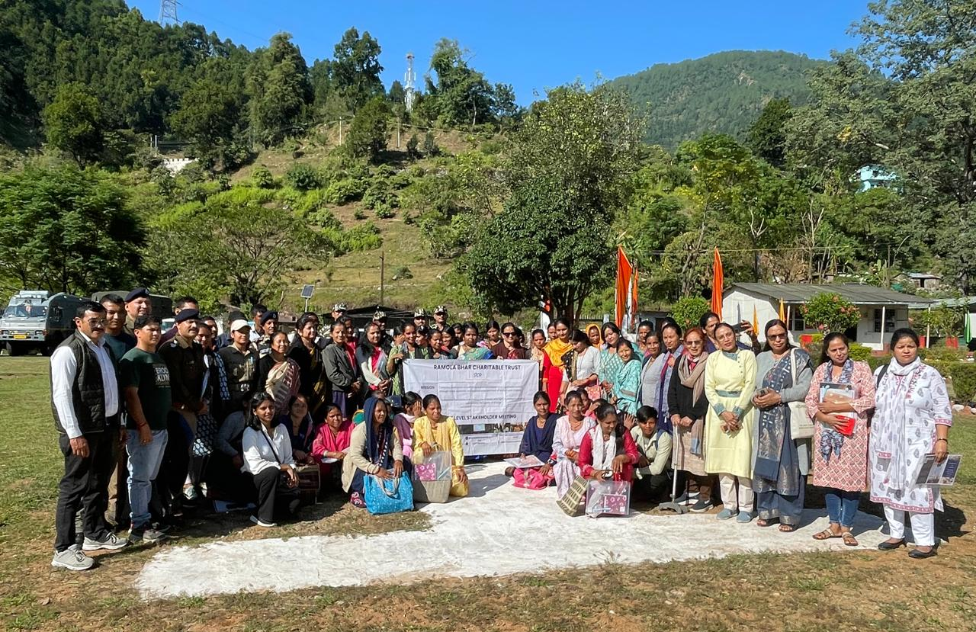
Over the past five years, STOP has been working and extending its outreach to Uttarakhand state of India, especially in the Himalayan regions bordering Nepal to fight against Cross-border human trafficking. In September-October 2024, STOP successfully conducted a series of Slake-holder meetings in Nepal bordering Uttarakhand districts of Udham Singh Nagar, Champawat and Pithoragarh.
On 23rd October 2024, STOP held its second stakeholder meeting in collaboration with SSB (Sashastra Seema Bal) Camps, a unit of Indian National Army located in Jauljibhi, as shown in the picture given above. Jauljibhi is a small village situated in the Indo-Nepal border within the Pithoragarh district of Uttarakhand. In these bordering areas Nepal is divided from India through a long strain of river and therefore many international posts are made connecting India and Nepal through walk-over iron hanging bridges. These Himalayan regions have difficult geographical features, lack of infrastructure, inaccessibility and economic difficulties. SSB unit Indian National Army generously offered a conference hall in their campus to conduct the meeting and actively participated and supported for smooth execution of the event. Despite of difficulties with travel and commute, individuals attended the event with impressive numbers.
Many government dignitaries like DM (district magistrate), CDO (Chief Development Officer), SSB representatives (Sashastra Seema Bal), ASHA workers, Police representatives, DLSA, PLV, AHTU, One Stop Centre, DPO, women and child district officials, ICDS (Integrated Child Development Services), Childline, CDPO Mahila Kalyan etc. were present. From far regions and remote villages NGOs working with women and children, Nepal NGO representatives, media representatives, Panchayat leaders, community leaders and members also attended the meeting and participated in the discussion.
The meeting was marked with a fruitful discussion on POCSO Act 2012 (Protection of Children from Sexual Offences), ITPA (Immoral Traffic (Prevention) Act) 1956, cross-border trafficking and sexual violence against children. The meeting led to building a reassuring support network between the community, local government bodies, NGOs and other community institutes.

